Matt Rumschlag

SD2650

5/20/2015

Lab 5.2

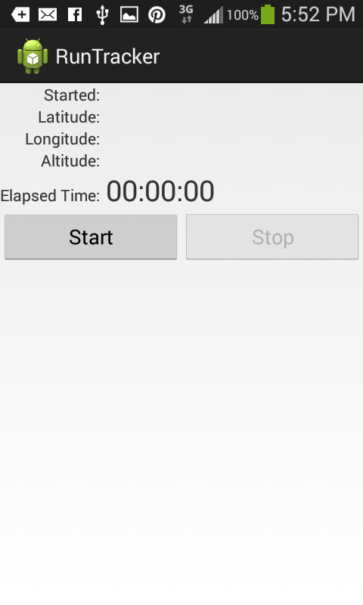

Question 1:

The requestLocationUpdates(String, long, float, PendingIntent) method is that is used for updates. The time in milliseconds between updates can be set by providing a long variable in the parameters.

Question 2:

You use the get method to get the activity so that if there is already an activity, then it is not destroyed.

Question 3:

When a run is started, it enables the buttons and sets the isTrackingRun() method as true.

